
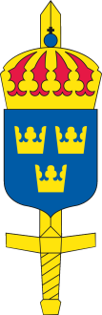
International Military Sports Council
Swedish Delegation

INVITATION FILE

Nordic Military Championship in Military Pentathlon

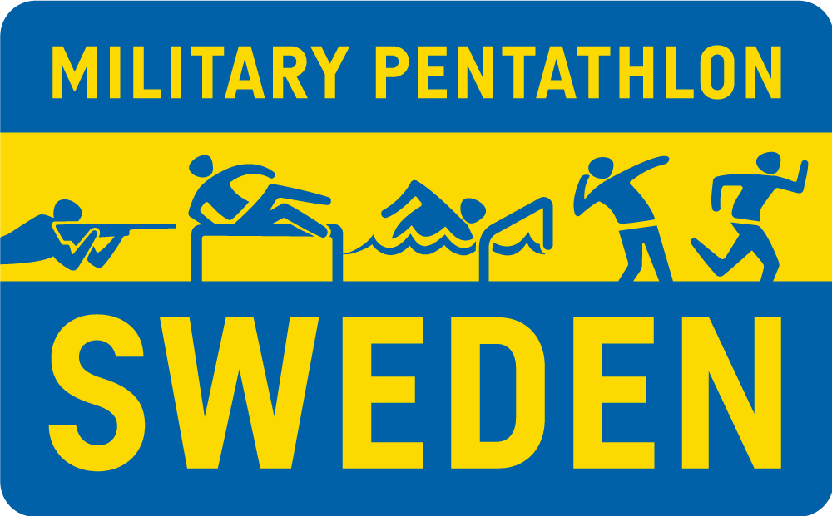

7 JUNE – 12 JUNE 2026, Swedish Air Defense Regiment, Halmstad, Sweden

CISM

“Friendship through Sport”

Chief of Delegation to CISM SWEDEN Lt Col Joachim Hahn
MHS K/FMIF, SE-107 86 STOCKHOLM - SWEDEN Phone: + 46 8 514 399 01, Fax: + 46 8 514 39 900
Mail: joachim.hahn@mil.se

To: The Chief of Delegation of Denmark, Finland, Norway and Sweden.

Subject: NORDIC MILITARY CHAMPIONSHIP IN MILITARY PENTATHLON 2026
Date: 23/10/25

The Swedish Armed Forces will host the
NORDIC MILITARY CHAMPIONSHIP IN MILITATY PENTATHLON
The Swedish Delegation to CISM has the great honor of inviting a mission representing the Armed Forces of your country to participate in the Nordic Military Championship in Military Pentathlon, which will be held in Halmstad from 7 June to 12 of June 2026.

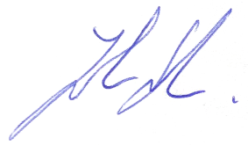

Lt Col Joachim Hahn
Chief of Swedish Delegation to CISM

ENCLOSED:
- Program
- Annex I - General Information
- Annex II - Preliminary Agreement
- Annex III A - Final Entry
- Annex III B - Composition of the mission

ANNEX I

PROGRAM

Sunday 7 JUNE - Arrival of missions to Garrison of Halmstad

Monday 8 JUNE - Training in throwing, obstacle run, obstacle swimming and cross-country

- Opening ceremony in uniform

- Team leaders meeting

Tuesday 9 JUNE - Shooting (morning)

- Obstacle run (afternoon)

Wednesday 10 JUNE - Throwing (morning)

- Obstacle swimming (evening)

Thursday 11 JUNE - Cross-country (morning)

- Nordic meeting

- Closing ceremony in uniform

Friday 12 JUNE - Departure of missions

COMPOSITION OF MISSION

Nordic countries (Denmark, Finland, Norway and Sweden)

Chief of delegation | 1
Team captain | 1
Coaches (men and women) | 2
Ad libitum | 1
Female competitors | 8
Male competitors | 12
In total of max | 25 participants

In accordance with Article 7.22 of the CISM regulations, all competitors must be active military personnel.

Participating nations are to be present in uniform for the Opening ceremony at 8 June.

LOCATION AND TRANSPORT OF THE COMPETITION

The Nordic Military Championship is hosted by the Swedish Armed Forces. The Swedish Air Defense regiment, located at the Swedish west coast 130 km south of Gothenburg, is responsible for the practical arrangements and is the center of the competitions.

Participating missions are responsible for their own travel expenses to and from Sweden and are requested to arrive at Halmstad railway station, Halmstad airport (domestic flight), Landvetter airport/Gothenburg or Sturup airport/Malmö. Arrivals by bus or car are possible directly to the Garrison. The organizer is responsible for local transportation in Sweden.

The missions are responsible for travel expenses to and from Sweden.

CONDITONS OF STAY

Team captain, coaches, physiotherapists and competitors will be accommodated in barracks of the garrison area.

REGULATIONS

The competitions will be governed by the following regulations:

- International Military Sports Council: CISM Regulations (Edition June 2025)
- General Regulations Governing Championship in the Nordic Framework 2022
- Regulations for Nordic Military Championship (NMC) in Military Pentathlon Edition 2023
- Regulations for Military Pentathlon Contest Edition 2020 Part A and Part B

SPORT FACILITIES

- Shooting will be carried out at a shooting range, 200 meters, with 20 targets and shooting direction southwest.
SIUS electronic scoring system will be used.
- The obstacle swimming will be performed in a 50-meter swimming pool with two competition lanes.
- The obstacle course is a four-curve course with two lanes.
- The throwing course has six stands for competition and three for warming up. The throwing direction is north. The grenades for the throwing competition, warming up included, will be provided by the organizer.
- The cross-country track is a 4 km loop and the surface is gravel and grass with approximately 100 m on asphalt.

The shooting, obstacle run, throwing and cross-country will take place near the Garrison. Obstacle swimming will take place at “Brottet” swim arena in Halmstad.

WEATHER CONDITIONS

Normal daytime weather conditions in June in Halmstad:
- Temperature: +15 to +20 C
- Rain might occur

PASSPORTS, VISAS, UNIFORM,
For information on passports, RFV (request for visit), visas for entry into Sweden, please contact the Swedish Embassy in your country.

The participating missions are permitted and obliged to wear uniform during the scheduled occasions.

DATES OF APPLICATION

Informal agreement, Annex II, sent to organizer before April 9, 2026.

Final entry with composition of mission and list of weapons, Annex III, sent to organizer
before May 7, 2026.

ADDRESS DURING THE CHAMPIONSHIP

Swedish Air Defense Regiment
Göteborgsvägen 1
301 80 HALMSTAD
SWEDEN

CORRESPONDENCE

All official mail concerning the competition should be sent to:

Tel: +46 70 970 29 37 (Karolina Persson)
E-mail: LV6-idrott@mil.se

ANNEX II

PRELIMINARY AGREEMENT

To be returned before April 9, 2026 Copy to:
Swedish Air Defense Regiment Swedish Delegation to CISM
Att: Karolina Persson MHS K/FMIF
Göteborgsvägen 1 SE- 107 86 STOCKHOLM
301 80 Halmstad SWEDEN
Sweden
E-mail: LV6-idrott@mil.se Fax: + 46 8 514 399 00
E-mail: fmif-mhsk@mil.se

NATION:

TOTAL NUMBER OF PARTICIPANTS:

 | Officials | Athletes | CSC Members | Total
Men
Women
Tota

MEANS OF TRANSPORT:

DATE:
SIGNATURE OF CHIEF OF DELEGATION
RANK/NAME:

Your Contact | Rank/Name
Your Contact | Phone
Your Contact | Fax
Your Contact | E-Mail

ANNEX III A

FINAL ENTRY

To be returned before May 7, 2026 Copy to:
Swedish Air Defense Regiment Swedish Delegation to CISM
Att: Karolina Persson MHS K/FMIF
Göteborgsvägen 1 SE- 107 86 STOCKHOLM
301 80 Halmstad SWEDEN
Sweden
E-mail: LV6-idrott@mil.se Fax: + 46 8 514 399 00
E-mail: fmif-mhsk@mil.se

NATION:

 | PLACE | DATE | FLIGHT Nr TRAIN Nr | TIME
ARRIVAL
DEPARTURE

MEANS OF TRANSPORT:

DATE:
SIGNATURE OF CHIEF OF DELEGATION
RANK/NAME:

Your Contact | Rank/Name
Your Contact | Phone
Your Contact | Fax
Your Contact | E-Mail

ANNEX III B

FINAL ENTRY - COMPOSITION OF THE MISSION

To be returned before May 7, 2026 Copy to:
Swedish Air Defense Regiment Swedish Delegation to CISM
Att: Karolina Persson MHS K/FMIF
Göteborgsvägen 1 SE- 107 86 STOCKHOLM
301 80 Halmstad SWEDEN
Sweden
E-mail: LV6-idrott@mil.se Fax: + 46 8 514 399 00
E-mail: fmif-mhsk@mil.se

NATION: OFFICIALS:

Function | Rank | Surname | First name | Male/female
Chief of mission
Team Captain
Coach male
Coach female
Ad libitum*

COMPETITORS: Men (*Only for Nordic countries)

MIL PIN | Rank | Surname | First name | Food allergy | Left hand shooter J/N | Best time in obstacle run | Best time in swim
*
*
*
*
*

COMPETITORS: Women (*Only for Nordic countries)

MIL PIN | Rank | Surname | First name | Food allergy | Left hand shooter J/N | Best time in obstacle run | Best time in swim
*
*
*
*

WEAPONS
 | Model | Cal. | Serial Number
1
2
3
4
5
6
7
8
9
10
11
12
13
14
15
16
17
18
19
20

Ammunition
Number | Cal.

In strict compliance with applicable CISM Regulations – Chapter VII, Article 7.22, I, the undersigned Chief of Delegation, hereby officially confirm that all athletes representing my nation in the CISM event are on active duty in my nation’s Armed Forces. I understand that sanctions may be imposed against my nation, my mission, my team, individual athletes, or myself for violation of this provision (CISM Regulations Chapter I, Art. 1.12).

DATE:
SIGNATURE OF CHIEF OF DELEGATION
RANK/NAME:

