# ../../../../../../../../Downloadlogo CISM POLANDInternational Military Sports Council

# Polish Delegation

**DGRSZ.IS.OWFiS.56.2.2019**



***INVITATION FILE***

../../../../../2019/01/LOGA/Logo_Track-and-Field_CISM_Regional_korekta.pdf

***27th  to 31st May 2019, Wrocław, Poland***

CISM

“Friendship through Sport”

Dear Chiefs of Delegation,

The General Command of the Polish Armed Forces has the honor to invite the mission representing your country to participate in *International Military Track & Field Championships* which will take place in Wrocław in the period 27-31 May 2019.

Warszawa, January 14th, 2019

**Chief of the Polish Delegation to CISM**

**Col. Tomasz BARTKOWIAK**

**ENCLOSED:**

* Distribution List
* Program
* General Information
* Annex 1 - Preliminary Agreement
* Annex 2a - Final Entry
* Annex 2b - Composition of Mission
* Annex 3 – Access to the location

Polish Delegation to CISM

Branch of Physical Education and Sports

General Command of the Polish Armed Forces

Ul. Żwirki i Wigury 103

00-912 Warsaw, Poland

Phone: +48 606 731 317 (maj. Krzysztof RYBCZYŃSKI)

E-mail: [wzswroclaw@ron.mil.pl](http://wzswroclaw@ron.mil.pl)  
NOTE that copy of all correspondence should be also sent to: [cismpoland@ron.mil.pl](mailto:cismpoland@ron.mil.pl)

**A. Distribution List**CISM governing bodies

* ***The Vice-President for Europe***
* ***CISM General Secretariat***
* ***The Chief of Liaison Office Europe***
* ***President CISM Sport Committee***

**To the Chief of Delegation of the following CISM Members Countries.**

|  |  |
| --- | --- |
| 1 | Belgium |
| 2 | Bulgaria |
| 3 | Czech Republic |
| 4 | Estonia |
| 5 | Finland |
| 6 | France |
| 7 | Germany |
| 8 | Greece |
| 9 | Hungary |
| 10 | Italy |
| 11 | Latvia |
| 12 | Lithuania |
| 13 | Netherlands |
| 14 | Norway |
| 15 | Romania |
| 16 | Slovakia |
| 17 | Spain |
| 18 | Sweden |
| 19 | Ukraine |
| 20 | United States |

**B. General Program of the Championship**

|  |  |
| --- | --- |
| DATE | ACTIVITY |
| Monday 27th May 2019 | * Arrival of Participants * Accreditation * Training |
| Tuesday 28th May 2019 | * Preliminary Meeting * Technical Meeting * Training * Opening Ceremony * Competition Day 1 * VIP Dinner – gift exchange |
| Wednesday 29th May 2019 | * Training * Competition Day 2 |
| Thursday  30th May 2019 | * Cultural Day * Closing Ceremony and Banquet |
| Friday 31st May 2019 | * Departures of all participants. |

**C. Composition of the Mission**

|  |  |
| --- | --- |
| Chief of Mission | 1 |
| Team Captain | 1 |
| Coaches | 2 (1-Track; 1-Field Events) |
| Doctor/Athletic Trainer/Physician | 1 |
| Athletes (Male/Female) | 20 (maximum 2 per individual event) |
| Total max | 25 |

**Please, be aware that only 11 teams (including Poland) can participate in this championship**. The first 10 countries which will register will be our guests!! According to the CISM Regulations (see CISM Police Manual, art. 3.19) only military personnel in active duty may participate in the competition.

**D. Access to the Location of the Competition.**

* The travel cost to the host country and respective return will occur under the responsibility of the participating country.
* The organizer will ensure the transportation from the place of arrival (Points of arrival) in the host country to the place of stay and the transport during the competitions as well.
* by bus/car:

**Centrum Szkolenia Wojsk Inżynieryjnych i Chemicznych**

**ul. Obornicka 108**

**50-961 Wrocław**

**Phone/fax: +48 261 652 087**

**Phone: +48 606 731 317 (maj. Krzysztof RYBCZYŃSKI)**

* Points of arrival and departure:

by plane:

**Wrocław-Strachowice Airport**

**ul. Graniczna 190**

**54-530 Wrocław**

**E. Conditions of Stay**

* Board, lodging and medical care will be at the expenses of the organizers.
* Participants who ask for services not covered by the Organizers, such as telephone calls, drinks, laundry etc. must pay the respective extra expenses.
* Additional people will not be accepted without an official written permission of the Organizers.
* Athletes and sport’s team crew will be accommodated in military unit in Centrum Szkolenia Wojsk Inżynieryjnych i Chemicznych, ul. Obornicka 108, 50-961 Wrocław.
* Chief of Mission will be accommodated in hotel in Wroclaw’s City Center.

**F. Regulations of the Championship**

* The CISM TRACK & FIELD Regulations, read and in conjunction with International Track& Field Committee rules and regulations, the currently valid CISM Regulations, as well as local rules discussed during the Preliminary and Technical Meeting will apply.
* The Competition is limited to military personal on active duty (see CISM Regulations, art.7.21).
* Each delegation may enter a maximum of two (2) athletes per individual event and one(1) team in each relay.
* During the Competition there will also be organized The International Track&Field Meeting of Edward Listos. Each Participant will be classified on this Meeting.
* There will be carried out Team Competition which will be calculated based on Official Medal Table.

Program of events shall include:

**Disciplines Men Women**

|  |  |  |
| --- | --- | --- |
| **DISCIPLINES** | **MEN** | **WOMEN** |
| 100 m |  | **X** |
| 200 m | **X** | **X** |
| 400 m | **X** | **X** |
| 800 m | **X** | **X** |
| 1500 m | **X** | **X** |
| 5000 m | **X** | **X** |
| 110 m hurdles | **X** |  |
| 400 m hurdles | **X** | **X** |
| 3000 m steeplechase | **X** | **X** |
| Long jump | **X** | **X** |
| High jump | **X** | **X** |
| Triple jump | **X** |  |
| Pole vault | **X** |  |
| Shot put | **X** | **X** |
| Discus | **X** | **X** |
| Javelin | **X** |  |
| Hammer Throw | **X** | **X** |

**G. Uniforms**

Service uniforms with jacket and tie are required for the Opening and Closing ceremonies as well as for a number of designated receptions. Jacket and tie are required for civilian members.  
Chiefs of Mission in full service uniforms.

Each participating nation shall provide one national flag (1.5 x 2.5m) and their national anthem on CD.

**H. Anti-Doping**

* Anti-Doping tests will be organized in accordance with the CISM Anti-Doping Regulations
  + Chapter IX.
* The number of tests shall be determined by the CISM Anti-Doping Commission.
* established during the Preliminary Meeting, according to the CISM Regulations.
* The tests will be performed according to the latest WADA Anti-Doping Code and
* Procedures.

**I. Customs and Visa Procedures**

Information concerning passport, visa and vaccination can be obtained from the Polish Embassy in your country.

Every Team Member is obligated to enter Passport Number in Final Entry (Annex 2a/b), which has to be sent to organizer to 15th April 2019.

**J. Weather Information**

The weather in May can range from a daily high of 15° - 25° Celsius to a daily low of 10° - 20° Celsius. The possibility of rain is moderate.  
**K. Registration Form - Deadlines**

|  |
| --- |
| * **Preliminary Agreement (Annex 1) 28th February 2019** * **Final Entry (Annex 2a/b) 15th April 2019**   Phone number and email address are required on the final entry form in case the organizing committee needs to contact you. |

**L. Correspondence.**

All official correspondence concerning the competition should be sent by email to:

Polish Delegation to CISM

Branch of Physical Education and Sports

General Command of the Polish Armed Forces

Ul. Żwirki i Wigury 103

00-912 Warsaw, Poland

Phone: +48 606 731 317 (maj. Krzysztof RYBCZYŃSKI)

E-mail: [wzswroclaw@ron.mil.pl](http://wzswroclaw@ron.mil.pl)  
NOTE that copy of all correspondence should be also sent to: [cismpoland@ron.mil.pl](mailto:cismpoland@ron.mil.pl)

**M. Currency.**

The currency in Poland is Polish Zloty. Currency exchange is available at the airport

and local banks. It is also possible to withdraw cash from an ATM.

**ANNEX 1**

***PRELIMINARY AGREEMENT***

To be returned before **28/02/2019**:

Polish Delegation to CISM

Branch of Physical Education and Sports

General Command of the Polish Armed Forces

Ul. Żwirki i Wigury 103

00-912 Warsaw, Poland

Phone: +48 606 731 317 (maj. Krzysztof RYBCZYŃSKI)

E-mail: [wzswroclaw@ron.mil.pl](http://wzswroclaw@ron.mil.pl)  
NOTE that copy of all correspondence should be also sent to: [cismpoland@ron.mil.pl](mailto:cismpoland@ron.mil.pl)

COUNTRY: **POLAND,,,,,,,,,,,,,,,,,,,,,,,**

TOTAL NUMBER OF PARTICIPANTS:

|  |  |  |  |
| --- | --- | --- | --- |
|  | Officials | Athletes | Total |
| Men |  |  |  |
| Women |  |  |  |
| Total |  |  |  |

|  |
| --- |
| MEANS OF TRANSPORT: \_\_\_\_\_\_\_\_\_\_\_\_\_\_\_\_\_\_\_\_\_\_\_\_\_\_\_\_\_\_\_\_\_\_\_\_\_\_  DATE:\_\_\_\_\_\_\_\_\_\_\_\_\_\_\_\_\_\_ \_\_\_\_\_\_\_\_\_\_\_\_\_\_\_\_\_\_\_\_\_\_\_\_\_\_\_\_\_\_\_\_\_\_\_\_\_\_\_\_ |
| SIGNATURE OF CHIEF OF DELEGATION | |
| RANK/NAME:\_\_\_\_\_\_\_\_\_\_\_\_\_\_\_\_\_\_\_\_\_\_\_\_\_\_\_\_\_\_\_\_\_\_\_\_\_\_\_ | |
|  | |

|  |  |  |
| --- | --- | --- |
| **Your**  **Contact** | **Rank/Name** |  |
| **Phone** |  |
| **Fax** |  |
| **E-mail** |  |

**ANNEX 2a**

***FINAL ENTRY***

To be returned before **15/04/2019**:

Polish Delegation to CISM

Branch of Physical Education and Sports

General Command of the Polish Armed Forces

Ul. Żwirki i Wigury 103

00-912 Warsaw, Poland

Phone: +48 606 731 317 (maj. Krzysztof RYBCZYŃSKI)

E-mail: [wzswroclaw@ron.mil.pl](http://wzswroclaw@ron.mil.pl)  
NOTE that copy of all correspondence should be also sent to: [cismpoland@ron.mil.pl](mailto:cismpoland@ron.mil.pl)

COUNTRY: **POLAND,,,,,,,,,,,,,,,,,,,,,,,**

ARRIVAL AND DEPARTURE DETAILS:

|  |  |  |  |  |
| --- | --- | --- | --- | --- |
|  | **PLACE** | **DATE** | **TIME** | **FLIGHT / TRAIN / BUS Number** |
| **ARRIVAL** |  |  |  |  |
| **DEPARTURE** |  |  |  |  |

|  |
| --- |
| MEANS OF TRANSPORT: \_\_\_\_\_\_\_\_\_\_\_\_\_\_\_\_\_\_\_\_\_\_\_\_\_\_\_\_\_\_\_\_\_\_\_\_\_\_  DATE:\_\_\_\_\_\_\_\_\_\_\_\_\_\_\_\_\_\_ \_\_\_\_\_\_\_\_\_\_\_\_\_\_\_\_\_\_\_\_\_\_\_\_\_\_\_\_\_\_\_\_\_\_\_\_\_\_\_\_ |
| SIGNATURE OF CHIEF OF DELEGATION | |
| RANK/NAME:\_\_\_\_\_\_\_\_\_\_\_\_\_\_\_\_\_\_\_\_\_\_\_\_\_\_\_\_\_\_\_\_\_\_\_\_\_\_\_ | |
|  | |

|  |  |  |
| --- | --- | --- |
| **Your**  **Contact** | **Rank/Name** |  |
| **Phone** |  |
| **Fax** |  |
| **E-mail** |  |

**ANNEX 2b**

***FINAL ENTRY – DOMPOSITION OF THE MISSION***

To be returned before **15/04/2019**:

Polish Delegation to CISM

Branch of Physical Education and Sports

General Command of the Polish Armed Forces

Ul. Żwirki i Wigury 103

00-912 Warsaw, Poland

Phone: +48 606 731 317 (maj. Krzysztof RYBCZYŃSKI)

E-mail: [wzswroclaw@ron.mil.pl](http://wzswroclaw@ron.mil.pl)  
NOTE that copy of all correspondence should be also sent to: [cismpoland@ron.mil.pl](mailto:cismpoland@ron.mil.pl)

COUNTRY **POLAND,,,,,,,,,,,,,,,,,,,,,,,**

ARRIVAL AND DEPARTURE DETAILS:

|  |  |  |  |  |  |  |
| --- | --- | --- | --- | --- | --- | --- |
| **OFFICIALS** | | | | | | |
| **#** | **FUNCTION** | **SEX**  **(M / F)** | **RANK** | **SURNAME** | **GIVEN NAME** | **PASSPORT NUMBER** |
| **1** | **Chief of Mission** |  |  |  |  |  |
| **2** | **Team Captain** |  |  |  |  |  |
| **3** | **Track Coach** |  |  |  |  |  |
| **4** | **Field Events Coach** |  |  |  |  |  |
| **5** | **Doctor/Athletic Trainer/Physician** |  |  |  |  |  |

|  |  |  |  |  |  |  |  |
| --- | --- | --- | --- | --- | --- | --- | --- |
| **ATHLETES** | | | | | | | |
| **#** | **FUNCTION** | **RANK** | **SURNAME** | **GIVEN NAME** | **DOB (D / M / Y)** | **PASSPORT NUMBER** | |
| **1** | **Male athletes**  **Male athletes** |  |  |  |  |  | |
| **2** |  |  |  |  |  | |
| **3** |  |  |  |  |  | |
| **4** |  |  |  |  |  | |
| **5** |  |  |  |  |  | |
| **6** |  |  |  |  |  | |
| **7** |  |  |  |  |  | |
| **8** |  |  |  |  |  | |
| **9** |  |  |  |  |  | |
| **10** |  |  |  |  | |  |
| **11** |  |  |  |  | |  |
| **12** |  |  |  |  | |  |
| **13** |  |  |  |  | |  |
| **14** |  |  |  |  | |  |
| **15** |  |  |  |  | |  |
| **16** |  |  |  |  | |  |
| **#** | **FUNCTION** | **RANK** | **SURNAME** | **GIVEN NAME** | **DOB (D / M / Y)** | | **PASSPORT NUMBER** |
| **1** | **Female**  **Athletes** |  |  |  |  | |  |
| **2** |  |  |  |  | |  |
| **3** |  |  |  |  | |  |
| **4** |  |  |  |  | |  |
| **5** |  |  |  |  | |  |
| **6** |  |  |  |  | |  |
| **7** |  |  |  |  | |  |
| **8** |  |  |  |  | |  |
| **9** |  |  |  |  | |  |
| **10** |  |  |  |  | |  |
| **11** |  |  |  |  | |  |
| **12** |  |  |  |  | |  |
| **13** |  |  |  |  | |  |

|  |  |  |  |  |  |  |  |  |  |  |  |  |  |  |  |  |  |  |  |  |  |  |  |  |  |  |  |  |  |  |  |  |  |  |  |  |  |  |  |  |  |  |  |  |  |  |  |  |  |  |  |  |  |  |  |  |  |
| --- | --- | --- | --- | --- | --- | --- | --- | --- | --- | --- | --- | --- | --- | --- | --- | --- | --- | --- | --- | --- | --- | --- | --- | --- | --- | --- | --- | --- | --- | --- | --- | --- | --- | --- | --- | --- | --- | --- | --- | --- | --- | --- | --- | --- | --- | --- | --- | --- | --- | --- | --- | --- | --- | --- | --- | --- | --- |
| |  |  |  | | --- | --- | --- | | **PARTICIPATION IN PARTICULAR EVENTS** | | | | **EVENT** | **MALE**  **SURNAME / GIVEN NAME** | **FEMALE**  **SURNAME / GIVEN NAME** | | 100 m | **--------------------------------------** |  | | 200 m |  |  | | 400 m |  |  | | 800 m |  |  | | 1500 m |  |  | | 5000 m |  |  | | 110 m hurdles |  | **--------------------------------------** | | 400 m hurdles |  |  | | 3000 m steeplechase |  |  | | Long jump |  |  | | High jump |  |  | | Triple jump |  | **--------------------------------------** | | Pole vault |  | **--------------------------------------** | | Shot put |  |  | | Discus |  |  | | Javelin |  | **--------------------------------------** | | Hammer Throw |  |  |   In strict compliance with applicable **CISM Regulations – Chapter VII, Art. 7.22**, I, the undersigned Chief of Delegation, hereby officially confirm that all athletes representing my nation in the CISM event are on active duty in my nation’s Armed Forces. I understand that sanctions may be imposed against my nation, my mission, my team, individual athletes, or myself for violation of this provision (**CISM Regulations Chapter I, Art. 1.12**).  DATE:\_\_\_\_\_\_\_\_\_\_\_\_\_\_\_\_\_\_ \_\_\_\_\_\_\_\_\_\_\_\_\_\_\_\_\_\_\_\_\_\_\_\_\_\_\_\_\_\_\_\_\_\_\_\_\_\_\_\_ |
| SIGNATURE OF CHIEF OF DELEGATION | |
| RANK/NAME:\_\_\_\_\_\_\_\_\_\_\_\_\_\_\_\_\_\_\_\_\_\_\_\_\_\_\_\_\_\_\_\_\_\_\_\_\_\_\_ | |

|  |  |  |
| --- | --- | --- |
| **Your**  **Contact** | **Rank/Name** |  |
| **Phone** |  |
| **Fax** |  |
| **E-mail** |  |

**ANNEX 3**

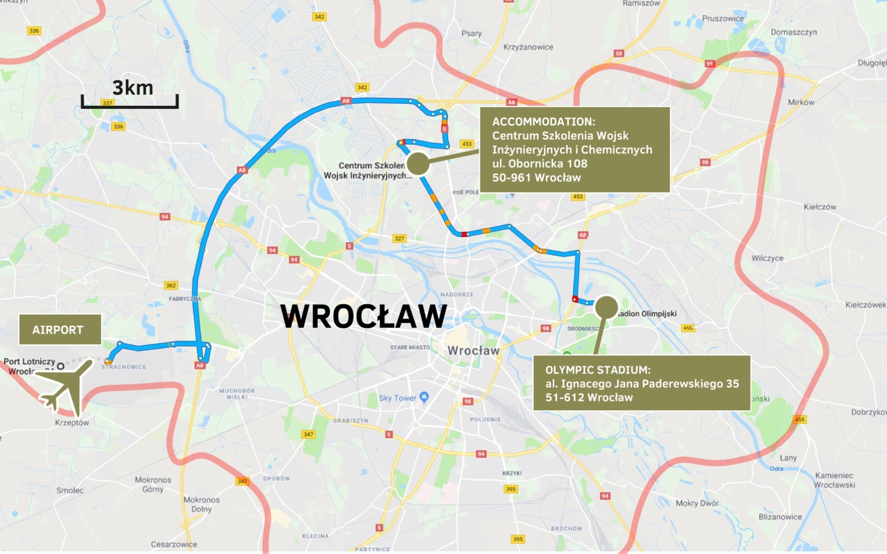OVERVIEW MAP