
ANNEX 1

Preliminary Agreement

To be returned before 07/06/2019:
Polish Delegation to CISM
Branch of Physical Education and Sports
General Command of the Polish Armed Forces
Ul. Żwirki i Wigury 103
00-912 Warsaw, Poland
Phone: +48 606309008
E-mail : oswris@ron.mil.pl
NOTE that copy of all correspondence should be also sent to: cismpoland@ron.mil.pl

NATION:

TOTAL NUMBER of PARTICIPANTS:
 | Officials | Athletes | Total
Men
Women
Total

Means of transPORT: _________________________________________

DATE:______________ | ___________________________________________________
 | SIGNATURE OF CHIEF OF DELEGATION
 | RANK/NAME:_______________________________________

Your Contact | Rank/Name
Your Contact | Phone
Your Contact | Fax
Your Contact | E-Mail
ANNEX 2a

FINAL ENTRY

To be returned before 20/07/2019:
Polish Delegation to CISM
Branch of Physical Education and Sports
General Command of the Polish Armed Forces
Ul. Żwirki i Wigury 103
00-912 Warsaw, Poland
Phone: +48 606309008
E-mail : oswris@ron.mil.pl
NOTE that copy of all correspondence should be also sent to: cismpoland@ron.mil.pl

NATION

 | PLACE | DATE | FLIGHT Nr  TRAIN Nr  BUS Nr | TIME
ARRIVAL
DEPARTURE

Means of transPORT: _________________________________________

DATE:______________ | __________________________________________________
 | SIGNATURE OF CHIEF OF DELEGATION
 | RANK/NAME:_______________________________________

Your Contact | Rank/Name
Your Contact | Phone
Your Contact | Fax
Your Contact | E-Mail
ANNEX 2b

FINAL ENTRY - COMPOSITION OF THE MISSION
To be returned before 20/07/2019:
Polish Delegation to CISM
Branch of Physical Education and Sports
General Command of the Polish Armed Forces
Ul. Żwirki i Wigury 103
00-912 Warsaw, Poland
Phone: +48 606309008
E-mail : oswris@ron.mil.pl
NOTE that copy of all correspondence should be also sent to: cismpoland@ron.mil.pl

NATION :

# | Function | Rank | Name and Surname | ID/Passport  Number | T-shirt size
1. | Chief of Mission
2. | Coach
3. | Male athlete
4. | Male athlete
5. | Male athlete
6. | Male athlete
7. | Male athlete
8. | Male athlete
9. | Female athlete
10. | Female athlete
11. | Female athlete
12. | Female athlete

In strict compliance with applicable CISM Regulations – Chapter VII, Art. 7.22, I, the undersigned Chief of Delegation, hereby officially confirm that all athletes representing my nation in the CISM event are on active duty in my nation’s Armed Forces. I understand that sanctions may be imposed against my nation, my mission, my team, individual athletes, or myself for violation of this provision (CISM Regulations Chapter I, Art. 1.12).

DATE:______________ | __________________________________________________
 | SIGNATURE OF CHIEF OF DELEGATION
 | RANK/NAME:_______________________________________

ANNEX 3

ROUTE FROM BORDER WITH GERMANY TO AIR FORCE TRAINING CENTRE (100 MINS)

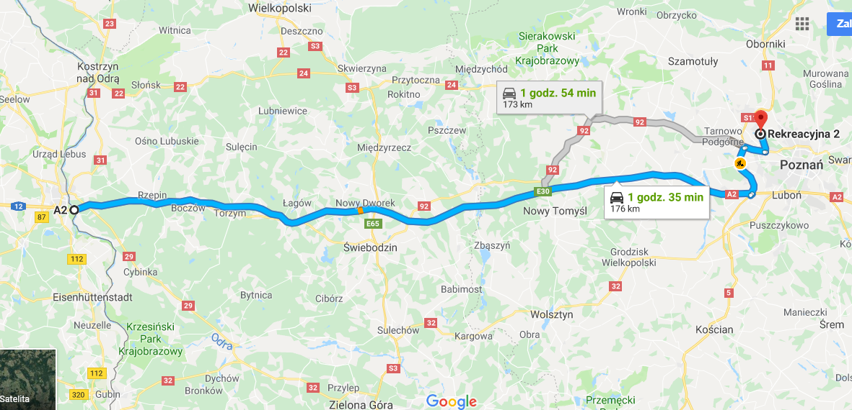
Air Force Training Centre
Kostrzyn Nad Odrą

ROUTE FROM CIVILIAN AIRPORT POZNAŃ ŁAWICA TO AIR FORCE TRAINING CENTRE (15 MINS)

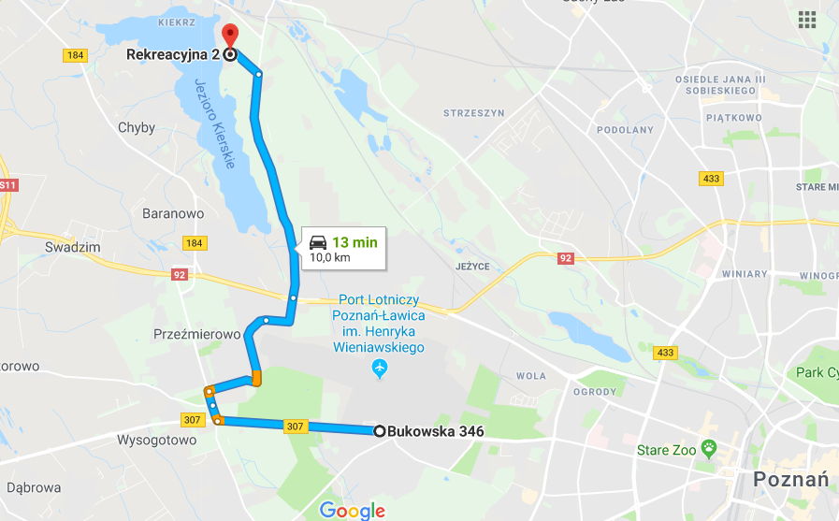
Air Force Training Centre
Ławica Airport

ROUTE FROM AIR FORCE TRAINING CENTRE TO KOBYLNICA AIRPORT (40 MINS)

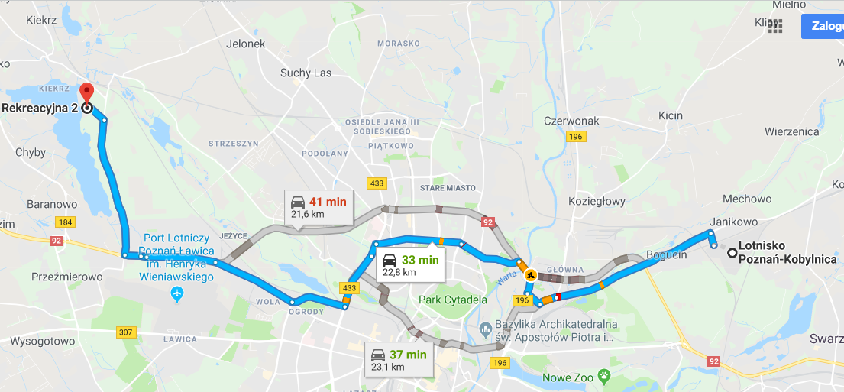
Kobylnica Airport
Air Force Training Centre

ANNEX 4

REQUEST OF PERMISSON ON PARACHUTE JUMPING AT POLISH ARMED FORCES BY JUMPERS OF ANOTHER ARMED FORCES

FROM: ..................................................................................................................................................

TO: The Commander of the OSWRiS - Poznań

ADDRESS: ul. Silniki 1, 61-325 Poznań

DATE: ......................................................................................................................................

SUBJECT: PERMISSION TO DO PARACHUTE JUMPS IN OSWRiS

IN REFERENCE TO: 2019 CISM PARACHUTING MILITARY TOURNAMENT

- As a commander (Head of civilian organization, etc.) of ....................................................................... ................................................................................................................................................................
(name of the unit/organization)

hereby I am confirming that:
1) ........................................................................................................................................................
(rank, name, number of jumps, type of jumps*)

…………………………………………………………………………………………………………

2) .........................................................................................................................................................
(rank, name, number of jumps, type of jumps*)

………………………………………………………………………………………………………..

from .................................................................................. have got authorization to take part in
(name of the unit)

parachute jumps in 2019 CISM Parachuting Military Tournament from 01.09.2019 to 07.09.2019.

2. The authorization covers the following activities:
- ground parachute training according to the Polish procedures;
- practical jumps from Polish aircraft with their own or the Polish Army owned parachutes (static line and free-fall as stated in paragraph 1.) in accordance with the Polish national procedures.

3. All the paratroopers (persons) listed in paragraph 1. have valid authorization for jumping in the
.........................................................................................................................................................
(name of the unit/service/organization etc.)

4. There are no medical or any other contraindications for executing parachute jumps by above listed personnel.

5. All the persons listed in paragraph 1. have got pending insurance covering parachute accidents, and will not claim any responsibilities from the Polish Military for any parachute accidents our soldiers might be involved in.

6. If approved please submit my request to the unit we will jump with (be trained) and inform us about it.

7. POC this documents is ......................................................... from .................................................. (rank and name) (name of the unit)

(Phone: …………....................... , fax: …………….…….………….e-mail: ......................................)

......................................
(rank, name)

*) SL - if the soldier / jumper is only “static line qualified”
FF - if the soldier / jumper is only “free fall qualified”
SL/FF - if the soldier / jumper is only “static line qualified” and “free fall qualified”

