INVITATION FILE

1st European Military Archery Championship

27 August to 2 September 2019
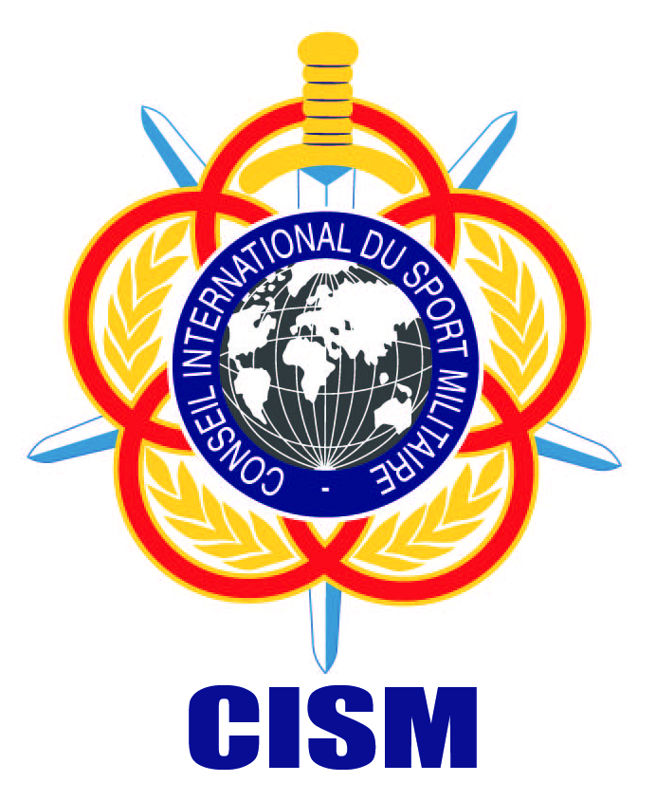
Tehran - IRAN

CISM

“Friendship through Sport”

Chief of Greek Delegation to CISM – BoD Member
Captain (Navy) Spyridon Andriopoulos
37 Kifisias Ave,
P.C. 153 21 Marousi – Attica - Greece
Supreme Military Sports Council of Hellenic Armed Forces
Phone: + 30 210 96 12 696
Fax: + 30 210 96 27 793
Mobile: + 30 6947 931 632
Mail: greek.cism.office@gmail.com

To: See Distribution List.
Subject: 1st CISM European Military Archery Championship 2019
Date: 27 August to 2 September 2019

Dear Chief of Delegation
On behalf of the Hellenic Armed Forces I have the honor to invite a mission representing your Armed Forces to participate in the 1st European Military Archery Championship, held in Thermopylae - Lamia, from 27 August to 2 of September 2019.
We look forward to seeing you in Thermopylae-Lamia-Greece.

Chief of the Greek Delegation to CISM
Captain (Navy) Spyridon Andriopoulos

ENCLOSED:

ENCLOSED:
- Distribution List;
- Program;
- General Information;
- Annex 1 - Preliminary Agreement;
- Annex 2a - Final Entry – Composition of the Mission;
- Annex 2b – Final Entry – Commitment by the Chief of Mission;
- Annex 3 – Final Entry – Travel data.

Distribution List

1. President of CISM.
2. Vice-President Europe.
3. CISM Secretary General.
4. Chief of European Liaison Office.
5. President and Members of CISM Sport Committee.
6. Chiefs of Delegation of CISM Members Countries (see next page, please)

To the Chiefs of Delegation of the following CISM Members Countries:
# | Nom/Name | # | Nom/Name | # | Nom/Name
1 | Albanie, R. /Albania, R. | 15 | Ex-Rép. Yougoslave de Macédoine /Former Yugoslav Repulic of Macedonia | 29 | Norvège, Royaume / Norway, Kingdom
2 | Allemagne, R.F. / Germany, F.R. | 16 | Finlande, R. / Finland, R. | 30 | Pays-Bas, Royaume/  The Netherlands, Kingdom
3 | Arménie / Armenia | 17 | France, R. | 31 | Pologne, R. / Poland, R.
4 | Autriche, R. / Austria, R. | 18 | Géorgie, R. / Georgia, R. | 32 | Portugal, R.
5 | Azerbaïdjan/ Azerbaijan | 19 | Grèce, R. / Greece, R. | 33 | Roumanie / Romania
6 | Bélarus / Belarus | 20 | Hongrie, R. / Hungary, R. | 34 | Russie, Fédération / Russia, Federation
7 | Belgique, Royaume / Belgium, Kingdom | 21 | Irlande, R / Ireland, R. | 35 | Serbie / Serbia
8 | Bosnie-Herzégovine / Bosnia Herzegovina | 22 | Italie, R. / Italy, R. | 36 | Slovaquie, R. / Slovakia, R.
9 | Bulgarie, R. / Bulgaria, R. | 23 | Lettonie / Latvia | 37 | Slovénie, R. / Slovenia, R.
10 | Chypre, R. / Cyprus, R. | 24 | Lituanie, R. / Lithuania, R. | 38 | Suède, Royaume : Sweden,Kingdom
11 | Croatie, R. / Croatia, R. | 25 | Luxembourg, G.D. | 39 | Suisse, Conféd. / Switzerland, Confed.
12 | Danemark, Royaume / Denmark, Kingdom | 26 | Malte / Malta | 40 | Rép. Tchèque / Czech Republic
13 | Espagne, Royaume / Spain, Kingdom | 27 | Monaco | 41 | Turquie, R. / Turkey, R.
14 | Estonie,R. / Estonia, R. | 28 | Monténégro | 42 | Ukraine

General Program of the Championship

DATE | ACTIVITY
27 August  Tuesday | - Arrival of Participants
28 August  Wednesday | - Preliminary Meeting  - Training  - Opening Ceremony
29 August  Thursday | - Competitions
30 August  Friday | - Competitions
31 August  Saturday | - Finals  - Closing Ceremony
1 September  Sunday | - Cultural day  - Exchange Gift and Banquet
2 September  Monday | - Departure of all participants.

Composition of the Mission
- 1 Chief of Mission
- 1 Team Captain
- 2 Coach (Men/ Women)
- 1 Physician/Masseur/ad libitum
- 1 Judge
- 6 Men (3 Recurve / 3 Compound )
- 6 Women (3 Recurve / 3 Compound )
- 3 Men Disabled (Recurve)

Total: maximum 21 members

Access to the Location of the Competition
Venue: Athens International Airport ¨El. Venizelos¨
The cost of travel to and from the host country will be the responsibility of the participating country.
The organizer will ensure the transportation from the place of arrival in the host country to the place of stay and also the transport during the competitions

Conditions of Stay
During their stay in Thermopylae-Lamia, missions will be guests of the Hellenic Armed Forces from 27 August to 2 September 2019. Full Board and lodging will be at the expenses of the organizer.
Extra expenses (telephone, drinks, laundry, etc.) must be paid by the consumers.
Any cost before the foreseen arrival date and/or after the departure date must be covered by the participants.
Additional accompanying persons shall pay for their own hotel accommodation. The organizer will help & provide reservation as requested.

Regulations of the Championship.
General Regulations: CISM Regulations
Sports Regulations: based on the rules and Regulations of the World Archery
Federation.

Anti-doping
Anti-Doping tests will be conducted in accordance with the CISM Regulations – Chapter IX, CISM Anti-Doping Rules, the concerned CISM Sports Regulations, the concerned International Federation Rules, and all WADA rules, mainly the World Anti-Doping Code, and the International Standard for Testing.
The number and type of tests, as well the athletes to be tested shall be determined by the CISM Anti-Doping Commission.
In case an athlete has a Therapeutic Use Exemption (TUE), the Chief of Delegation should send this TUE to the CISM GS until 30 days before the Opening Ceremony. This TUE will be submitted to the TUE Commission to analysis and further approval.

Uniforms.
Military uniform is to be worn at the official events as scheduled.

Customs and Visa Procedures.
For information on requirements, please contact the Hellenic Embassy or Consulate
serving your country. Application for visa is the responsibility of the participating
delegations.

Weather Conditions
Daily maximum: 32 Degrees C
Daily minimum: 16 Degrees C

Registration Forms Deadlines
Preliminary Agreement (Annex I). To be sent not later than 3rd June, 2019.
Final Entry (Annex II). To be sent not later than 10th July, 2019.

Correspondence
Supreme Military Sports Council of Hellenic Armed Forces
37 Kifisias Ave / PC 151 23 – Attica - Greece
Tel.: +30 210 96 12 696
Fax: +30 210 96 27 793
Mobile: +30 6947 931 632
E-mail: greek.cism.office@gmail.com
Correspondence officer: P.Sgt Sofia Andriopoulou
ANNEX 1

Preliminary Agreement
To be returned before 3 June 2019:
Organizing Committee:
Supreme Military Sports Council of Hellenic Armed Forces
Tel.: +30 210 96 12 696
Fax: +30 210 96 27 793
Mobile: +30 6947 931 632
E-mail: greek.cism.office@gmail.com

NATION:

TOTAL NUMBER of PARTICIPANTS:
 | Officials | Athletes | CSC members | Referees | Total
Men
Women
Men with Disabilities
Total

Means of transPORT: _________________________________________
DATE:______________ | ___________________________________________________
 | SIGNATURE OF CHIEF OF DELEGATION
 | RANK/NAME:_______________________________________

Your Contact | Rank/Name
Your Contact | Phone
Your Contact | Fax
Your Contact | E-Mail
ANNEX 2a

FINAL ENTRY
To be returned before 10 July 2019:
Organizing Committee:
Supreme Military Sports Council of Hellenic Armed Forces
Tel.: +30 210 96 12 696
Fax: +30 210 96 27 793
Mobile: +30 6947 931 632
E-mail: greek.cism.office@gmail.com

NATION :

 | PLACE | DATE | FLIGHT Nr | TIME
ARRIVAL
DEPARTURE

Means of transPORT: _________________________________________

DATE:______________ | __________________________________________________
 | SIGNATURE OF CHIEF OF DELEGATION
 | RANK/NAME:_______________________________________

Your Contact | Rank/Name
Your Contact | Phone
Your Contact | Fax
Your Contact | E-Mail
ANNEX 2b

FINAL ENTRY - COMPOSITION OF THE MISSION
To be returned before 10 July 2019:
Organizing Committee:
Supreme Military Sports Council of Hellenic Armed Forces
Tel.: +30 210 96 12 696
Fax: +30 210 96 27 793
Mobile: +30 6947 931 632
E-mail : greek.cism.office@gmail.com

NATION :

# | Function | Rank | Last Name | First Name
1. | Chief of Mission
2. | Team Captain
3. | Coach Recurve
4. | Coach Compound
5. | Judge
6. | Male athlete  Recurve
7. | Male athlete  Recurve
8. | Male athlete  Recurve
9. | Male athlete  Compound
10. | Male athlete  Compound
11. | Male athlete  Compound
12. | Female athlete  Recurve
13. | Female athlete  Recurve
14. | Female athlete  Recurve
15. | Female athlete  Compound
16. | Female athlete  Compound
17. | Female athlete  Compound
18. | Male Athlete  with Disabilities  Recurve
19. | CSC Member

In strict compliance with applicable CISM Regulations – Chapter VII, Art. 7.22, I, the undersigned Chief of Delegation, hereby officially confirm that all athletes representing my nation in the CISM event are on active duty in my nation’s Armed Forces. I understand that sanctions may be imposed against my nation, my mission, my team, individual athletes, or myself for violation of this provision (CISM Regulations Chapter I, Art. 1.12).
DATE:______________ | __________________________________________________
 | SIGNATURE OF CHIEF OF DELEGATION
 | RANK/NAME:_______________________________________
ANNEX 2c

FInal Entry - COMMITMENT BY THE CHIEF OF MISSION
To be returned before 11/October/2018:
Organizing Committee:
Supreme Military Sports Council of Hellenic Armed Forces
Tel.: +30 210 96 12 696
Fax: +30 210 96 27 793
Mobile: +30 6947 931 632
E-mail: greek.cism.office@gmail.com

NATION :

The undersigned, Chief of Mission declare that he has read the CISM Regulations and moreover understood the following prescriptions:

Article 7.21. PARTICIPATION - MILITARY STATUS
A. Only military personnel on active duty in Armed Forces may take part in competitions organized by CISM.
B. No one may be recalled to active duty in the Armed Forces for the purpose of participating in a CISM competition. In the case of an intermittent military service, the athletes regularly recalled may not take part in CISM competitions, under any circumstances, if more than 18 months have elapsed between this recall and the end of their last call to arms.
C. Exceptions to the above may be authorized by the General Assembly, upon recommendation of the Board of Directors.
D. All military participants in a CISM event shall be in possession of proper documentation which signifies active military service of the member nation he represents. The documentation can be:
1. A valid military identity card for those athletes who are authorized to present their military identity cards abroad,
2. A form of verification (in English and/or French) of military status accompanied by a passport.
E. By signing the final entry, the Chief of Delegation confirms the military status of the participating athletes. If there are last minute changes in the participation of the athletes, the verification file may be signed by the Chief of Mission, but shall be confirmed by the Chief of Delegation by official letter.
F. If one of these documents is not available, participation is refused.

Article 7.30. CHIEF OF MISSION
- Chief of Mission
- Chiefs of Mission shall be familiar with CISM regulations.
- Missions must not only participate or be present at sports events, they are also required to participate in information conferences on CISM, study days, commemorative and cultural events and ceremonies organized by the host nation.

- Conduct of a mission
- The Chief of Mission is responsible for the behavior of his team in sports and general discipline. He shall ensure that members of his mission respect the rules and directives prescribed by CISM and organizers of the championship. The respect of schedules is particularly important as they form the basis for the effective conduct of competitions and ceremonies. Instances of indiscipline or poor sportsmanship will be handled by Championship officials and may result in the disqualification of individual athletes or teams.
- The Chief of Mission shall also enforce the rules concerning behavior and dress during the ceremonies. He plays an important role in promoting the CISM spirit among his mission, a spirit represented by friendly attitude towards other missions, courtesy towards organizers and fair-play in competition. The mission, who does not wear military uniforms during the opening ceremony of a Championship, will not be authorised to take part in the Championship. The Official CISM Representative will communicate this decision.

Article 8.6. ABSENCE OF A MISSION WITHOUT NOTIFICATION
If a mission which submits a preliminary agreement and/or final entry is absent without notifying the host nation in time, a sanction will be imposed (Regulations Art. 1.12).

Article 8.17. RULES OF STAY
A. General
1. The Chiefs of Mission are responsible for the discipline of their mission. The missions fall under the jurisdiction of the organizing nation. During events, all athletes present on the playing fields are equal before the jury, the referees and to themselves. No one may use his rank to impose his views on sports matters.
2. Civilian members of the missions shall conform to the discipline accepted by all other participants.
B. Military uniforms
1. Unless otherwise approved by the Official CISM Representative, all participants shall wear military uniform during official ceremonies such as the opening and closing ceremonies and medal-awarding ceremonies. Individuals without proper uniform will not be allowed to participate in the championship.

2. The presentation of medals takes place, in principle, during the closing ceremony. The presentation of medals may be done in sports uniform, if for organizational reasons it is not possible to wear military uniforms. This is the case e.g. when the presentation immediately follows a championship sports event. Sports uniforms shall respect the corresponding national criteria (training suit, sports shoes, etc.) Displaying the national flag on the podium by the recipient (athlete or team) at a medal awarding ceremony is forbidden. Individuals failing to respect these prescriptions shall not receive their medal(s) during the official ceremonies.
C. Forbidden actions
1. In conformity with the statutes and traditions of CISM, any political or religious propaganda during a CISM event, in particular the dissemination of documents, pictures, brochures, reviews, etc. is strictly forbidden.
2. Any contravention shall result in the exclusion of the mission from further competition and may result in additional sanctions (Regulations Art. 1.12).

Article 8.19. ACCOMMODATIONS
E. All missions, including those of the host nation, shall be accommodated under the same conditions. If the conditions are in accordance with the CISM norms and standards, the missions are expected to accept the accommodation provided by the organizing nation.
Any mission that does not accept the accommodations provided by the organizing nation and judged as adequate by the Official CISM Representative will not be allowed to participate in the championship.

DATE:________________ | __________________________________________________
 | SIGNATURE OF CHIEF OF MISSION
 | RANK/NAME:_____________________________________

