ANNEX 1
PRELIMINARY AGREEMENT
To be returned before 1st June 2016:
To:  Latvian Delegation to CISM  Krustabaznicas street 9, Riga, LATVIA  LV- 1006  Tel.: +371 67556952  Fax.: +371 67556952  E-mail: vents.graudins@mil.lv; indra.cavare@mil.lv | Copy:  CISM European Liaison Office  Joint Support Service Command  Armed Forces Training Department  Fontainengraben 150  D-53123 Bonn  Germany  Fax: (+49) 22855042714  Email: cismeurope@bundeswehr.org

NATION:
NO
YES
PARTICIPATION:

Participants
Chief of Delegation | Total numbers
Delegates
Spouses
Total number of participants
Means of transport | Air Train Car

DATE:
RANK – NAME – SIGNATURE OF CHIEF OF DELEGATION

Your contact | Rank/Name
 | Phone
 | Fax
 | E-Mail

ANNEX 2a

FINAL ENTRY

To be returned before 29th August 2016
To:  Latvian Delegation to CISM  Krustabaznicas street 9, Riga, LATVIA  LV- 1006  Tel.: +371 67556952  Fax.: +371 67556952  E-mail: vents.graudins@mil.lv; indra.cavare@mil.lv | Copy:  CISM European Liaison Office  Joint Support Service Command  Armed Forces Training Department  Fontainengraben 150  D-53123 Bonn  Germany  Fax: (+49) 22855042714  Email: cismeurope@bundeswehr.org

NATION:

 | PLACE | DATE | FLIGHT Nr.  TRAIN Nr. | TIME
ARRIVAL
DEPARTURE

MEANS OF TRANSPORT:

DATE:
RANK – NAME – SIGNATURE OF CHIEF OF DELEGATION

Your contact | Rank/Name
 | Phone
 | Fax
 | E-Mail

ANNEX 2b
FINAL ENTRY – COMPOSITION OF THE DELEGATION

To be returned before 29th August 2016
To:  Latvian Delegation to CISM  Krustabaznicas street 9, Riga, LATVIA  LV- 1006  Tel.: +371 67556952  Fax.: +371 67556952  E-mail: vents.graudins@mil.lv; indra.cavare@mil.lv | Copy:  CISM European Liaison Office  Joint Support Service Command  Armed Forces Training Department  Fontainengraben 150  D-53123 Bonn  Germany  Fax: (+49) 22855042714  Email: cismeurope@bundeswehr.org

NATION:

 | Participants |  |  | Accommodations
A/N | CoD/Delegates  (Rank, Name, Surname) | Function | Accompanying / Spouses | Single room | Double room
1.
2.
3.
4.
5.
6.
1 CoD, 2 Delegates, maximum 3 spouses, at all max. 6 persons

DATE:
RANK – NAME – SIGNATURE OF CHIEF OF DELEGATION

ANNEX 3

HOTEL RESERVATION APPLICATION FORM

NATION:
 | Participants |  |  | Accommodations
A/N | CoD/Delegates  (Rank, Name, Surname) | Function | Accompanying / Spouses | Single room | Double room
1.
2.
3.
4.
5.
6.

Credit card type |  |  | Card information
VISA | MASTER | AMERICAN EXPRESS | Number
 |  |  | Expiration
- 7 days before arrival money from the credit card will be charged for hotel services 100%.
It will be non-refundable.
For any changes (date, cancellation) it must be done no later than 7 days before arrival.

ARRIVAL DATE: DEPARTURE DATE:
Your contact | Rank/Name
 | Phone
 | Fax
 | E-Mail

DATE:
RANK – NAME – SIGNATURE OF CHIEF OF DELEGATION
Baltic Beach Hotel
Juras street 23/25
Jurmala, LV-2015, LATVIA
Tel: +371 67771400
Fax: +371 67771420
E-booking: res@balticbeach.lv
Web: www.balticbeach.lv

MAPS – DIRECTIONS
By air: Riga International Airport – Baltic Beach Hotel (~18 km by car)
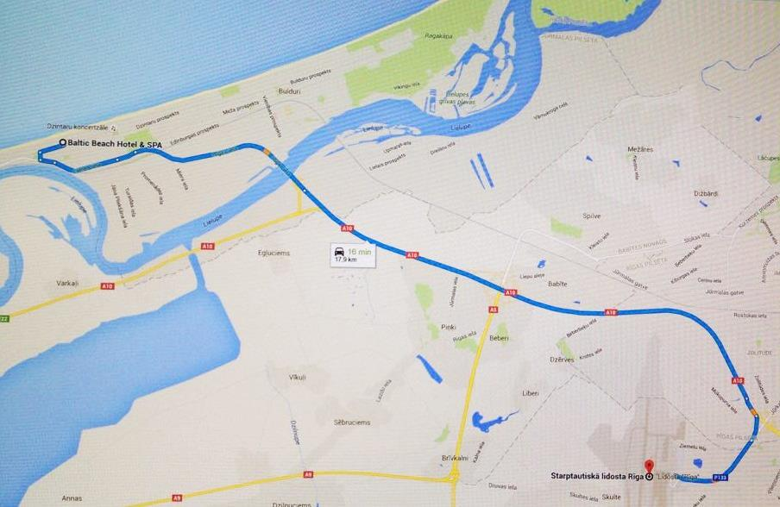

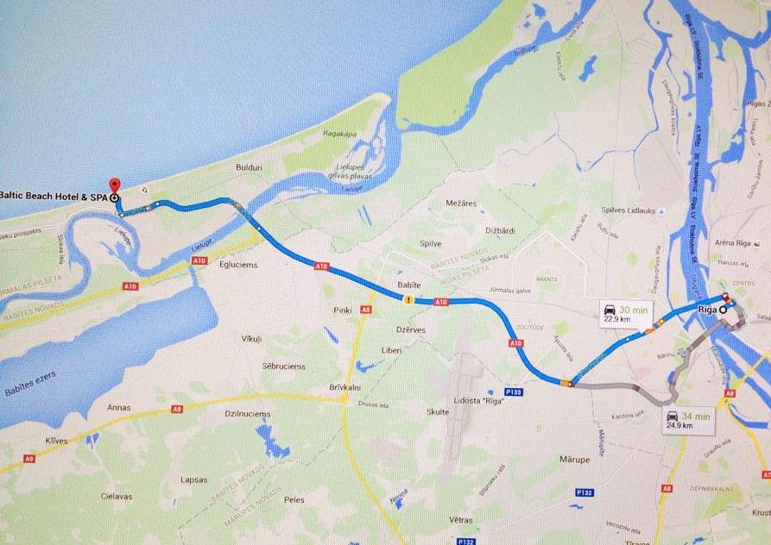
By train or bus: Riga International train station – Baltic Beach Hotel (25 km by car)

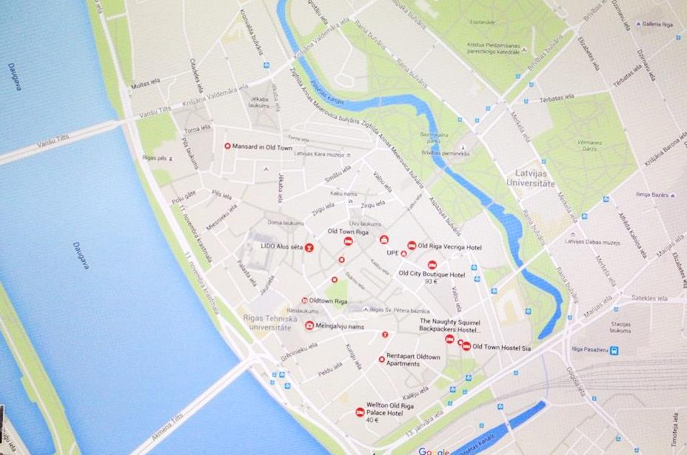
Riga Old town

